Here is the DEMO of the working of our web application.

This is the starting page of the our application. When we click on “go there”, then it will go to the registration page.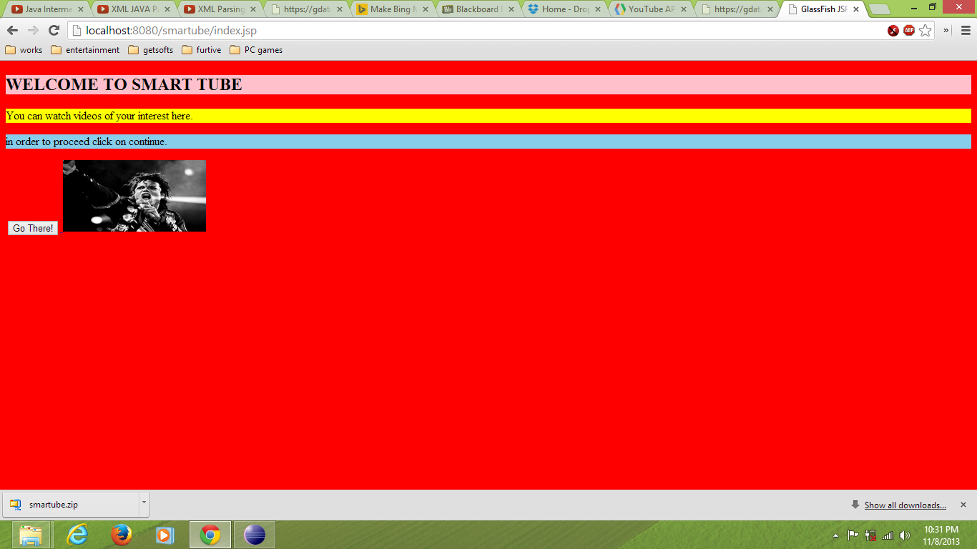

When we fill the fields in the registration page and after click on the “register” then it will go to the “ fill in preferences page”. If the user is already logged in then they will click on the “already registered” button. Then it will go to the “login” page and after that it will go to the preferences set page.

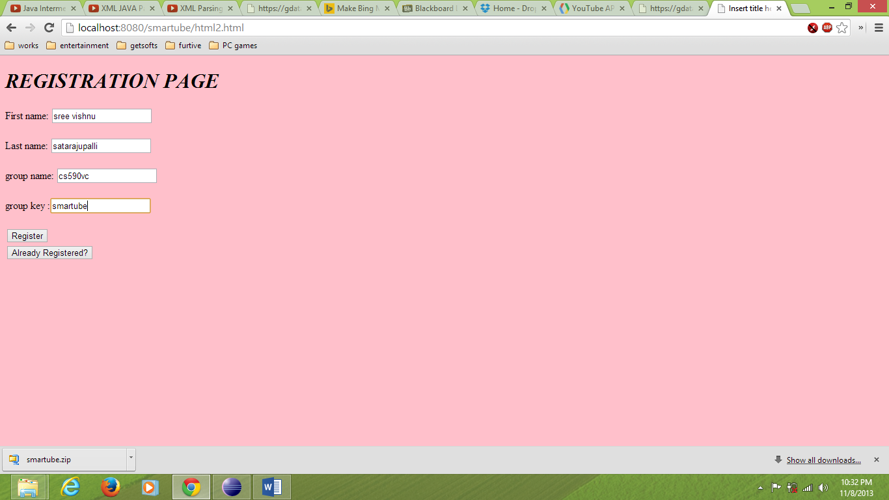

After filling the fields of the “fill your preferences” and click on submit then it will give the required results 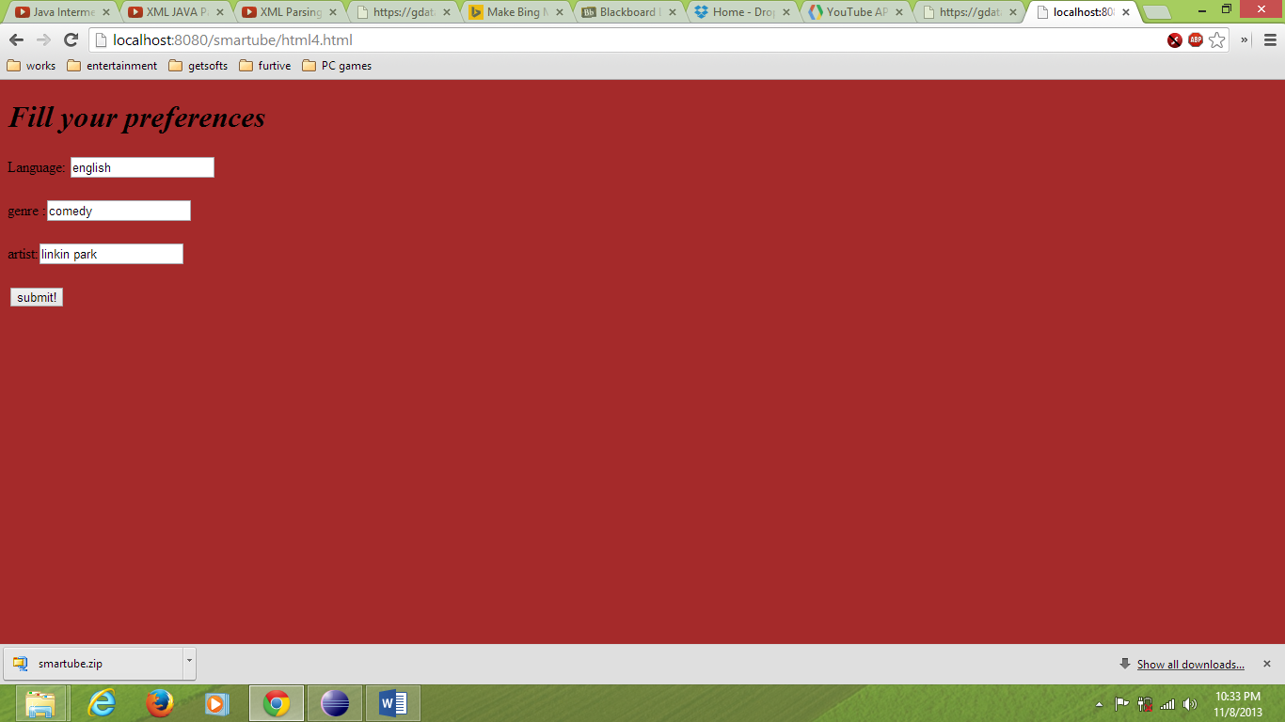

This is the XML data we get after setting the preferences in our application. Now we will give this XML data as an input to the Map Reduce algorithm, then it reduces and parses the input and gives the XML data as output.

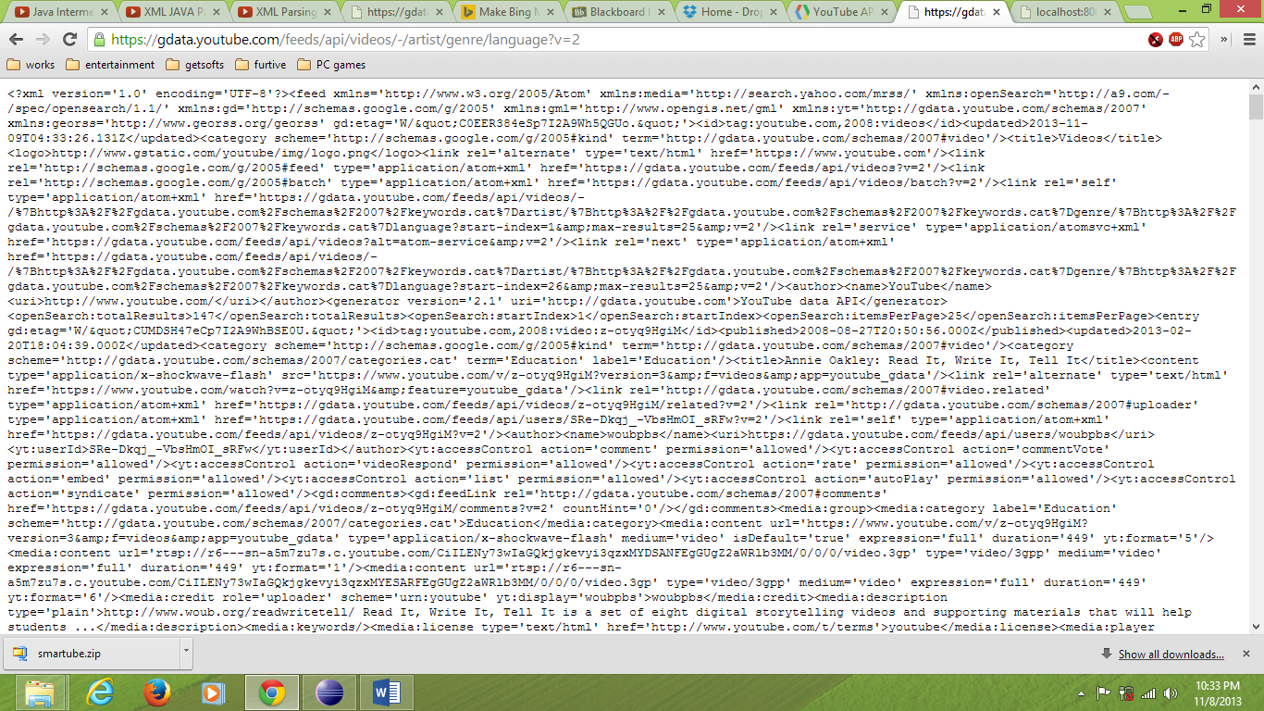

If we click in already registered then it will go to the LOGIN PAGE.

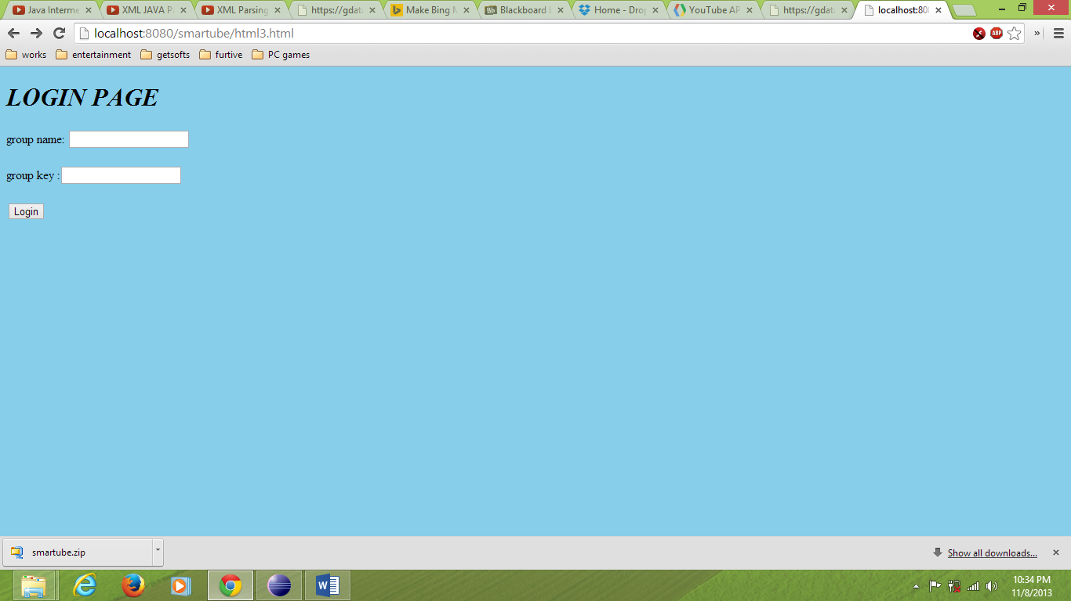

We have written map reduce code for sorting which we have submitted in the source code, for which results are not yet done. We will submit with the acquired results in few days.